**1.Install and start docker –**

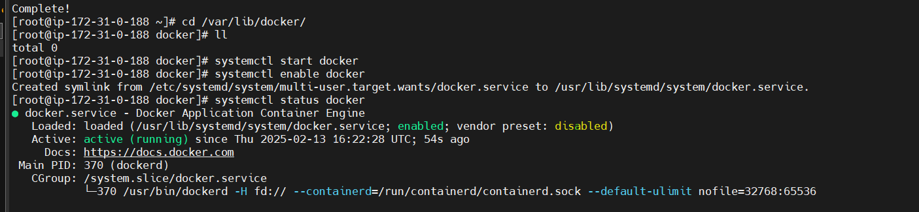

**2.check and download image**

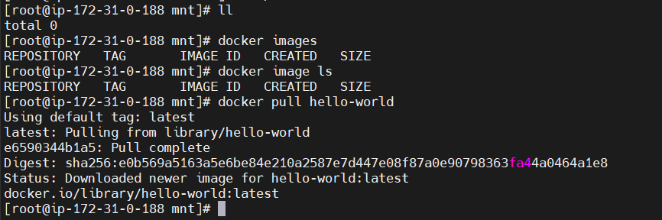

**3.check and download particular version**

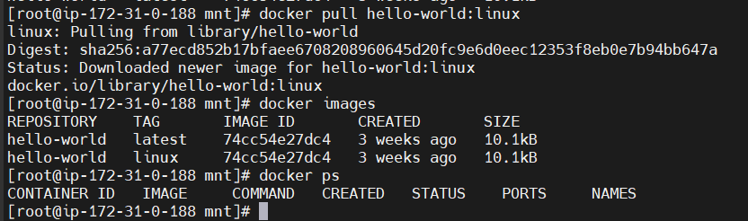

**4.execute container**

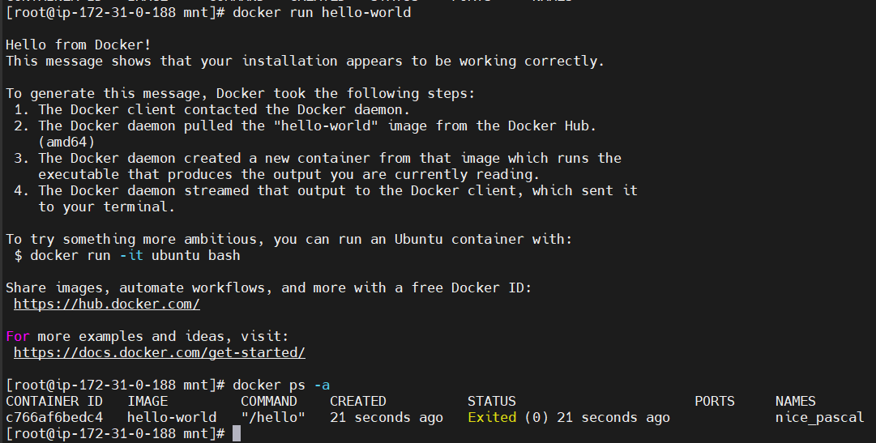

**5.Check and remove image**

